MINDSTORM EV3

Touch Sensor

## Mode – Touch Sensor (Default)

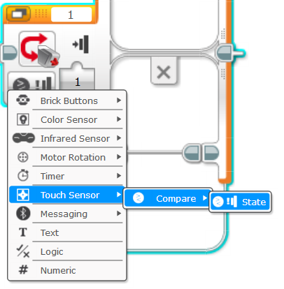The first mode is Touch Sensor Mode because it is the one that appears by default. When you click the mode button this is the list you will see. The touch sensor only has one mode, compare the state.

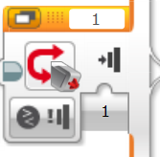This is the port number your sensor is in.



This is the condition to test.

* 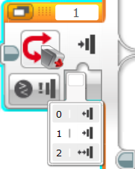 “0” will be TRUE when the sensor button comes out
* “1” will be TRUE when the sensor button goes in
* “2” will be TRUE when the button goes in and out or out then in quickly.
* The condition is FALSE whenever it is not TRUE.